FLUDHA

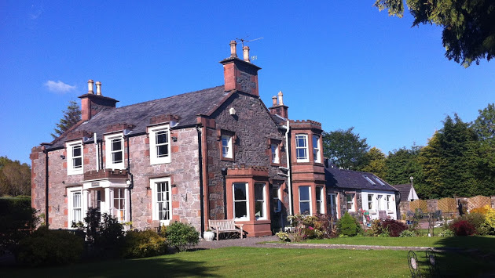

A HOUSE WITH A HISTORY.
INTRODUCTION.

Welcome to this very brief history of the building that you are staying in. The address for most of its life was, Fludha, Tongland Road, Kirkcudbright, Kirkcudbrightshire, Scotland. The New Statistical Account of Scotland, Volume IV, listed Fludha as one of the five mansion houses of the parish of Kirkcudbright in 1845 [interestingly, Janefield on the opposite side of the main road was another].
Prior to 1839 Fludha was a simple two room dwelling, very similar to another, which was later rebuilt as Fludha Cottage and stands just behind and to the north of the Fludha. We can chart how a rude dwelling became such an attractive dwelling and occupied such a prominent location.
Kirkcudbrightshire as a county disappeared in a local government reorganisation in 1975. Kirkcudbrightshire, Wigtonshire and Dumfriesshire were amalgamated into Dumfries & Galloway Council. The town of Kirkcudbright dates back to approximately 1200 and has been a Royal Burgh since 1455. However, there have been people living here from prehistoric through Celtic, Roman Norse, and Saxon periods. In the reign of the Stewart King James II [1437-60] the Scottish kings were keen to limit the power of the local earls, the Douglas’s. The granting of the status of Royal Burgh allowed the town to run its own affairs and to restrict the interference of the Earls of Douglas.
Fludha has been a hotel or guest house since opening in 2005 when Stephen and Christine Laycock bought the 2 acre property and the period house and sympathetically renovated the inside to achieve a 5*, six bedroom, hotel. In addition the gardens were landscaped to try to bring back some of the elegance of previous years.
Fludha has many links with some of the bigger houses in Kirkcudbrightshire and with one of the most famous buildings in America. Many of the previous owners have also had close links with Canada. Some previous owners have been doctors, perhaps not surprising when we consider the size of the house. Also the house has generally passed into the hands of family members when death called for the existing owner. A large proportion of the previous owners have been women.
We are very grateful to such people as Margaret Torrance and other sources, such as the autobiography by Stuart Lauchlan, that allowed us to put this brief history of the house and its links together.

FLUDHA IS BORN.

Our first mention of Fludha is of a small two room dwelling, rather than the current period mansion. We have a brief mention of it from Stuart Campbell Lauchlan. His mother and father, Mr and Mrs Joseph Campbell, owned, or lived in, Fludha from 1922 and he grew up there for at least some of his childhood. He has suggested that the property was rebuilt to its present shape and proportions in 1839. The two rooms became the dining room and a drawing room. Two acres of lawn and rough field were attached to the property, although it is not clear if this land was purchased at this time to add to the property. This land more or less corresponds to the existing footprint of the land today.
The new house was an impressive one and had been carefully chosen. Stonemasons, carpenters and builders produced the current shape of the house on classical lines, although we have no record of any architect yet. The average wage for a stonemason in Kirkcudbright in the 1840s was 2 shillings and 6 pence daily [12 ½ pence] and a house carpenter would expect to be paid 2 shillings [10 pence].
There seems to be a very strong American influence in the choice of the location for the new house and for the choice of name.
The first recorded occupants [through the 1841 Census] of Fludha were three ladies. They were Grace Maitland [nee Gordon] and her two step daughters, Elizabeth Agnes Maitland [Miss Betsy] and her sister, Susanna Poythress Maitland. Grace was the widow of David Maitland of Barcaple. There were many family links between Fludha and Barcaple, one of the more imposing mansion houses in the area. It had an estate of nearly 4,000 acres and a 21 acre park and was about 4 miles away across the rivers Dee and Tarff. In fact, one author described Fludha as a dower house for the Maitland women.
Miss Betsy was born in Virginia, USA in 1793. Her father, David Maitland, was a merchant and trader concerned largely with the eastern states. Tobacco was a very important, and lucrative, trade between the USA and Great Britain. Virginia was also a leading cotton producer and at this time cotton was in high demand in Britain. Around 1820, nearly half of all American imports were cotton. Tobacco exports were about one-fifth of cotton totals.
David Maitland married Susanna Poythress, the daughter of Joshua Poythress in Prince George, Virginia in 1788. Joshua owned the tobacco plantation on the crook of the James River, on the south side, halfway between Richmond and Williamsburg. The name of the plantation was the Flowerdew Plantation.
The Flowerdew Plantation is a very famous and historically important one in America today. Flowerdew Hundred was among the earliest English settlements in the New World, and its 1,400 acres contain some of the country's best preserved and most significant archaeological site. Flowerdew Hundred survived an Indian attack in 1622. Originally it was owned by Sir George Yeardley, the first Governor of Virginia. He was a very able and popular Governor and the economy of Virginia soon began to prosper.
The house, Flowerdew, was built in 1620 and the plantation was named after the Governor’s wife, Temperence Flowerdew. However, it may have been already farmed by Temperence’s brother and already named after him. The family originating from Norfolk, England. Temperence Flowerdew was one of the first Americans, arriving on the Falcon in 1609. For many years the Flowerdew Hundred [the name given to a grant of land] was a famous historical museum. It is also a site of archaeological importance and the excavations there have helped to fill in some of the early history of America and Virginia.
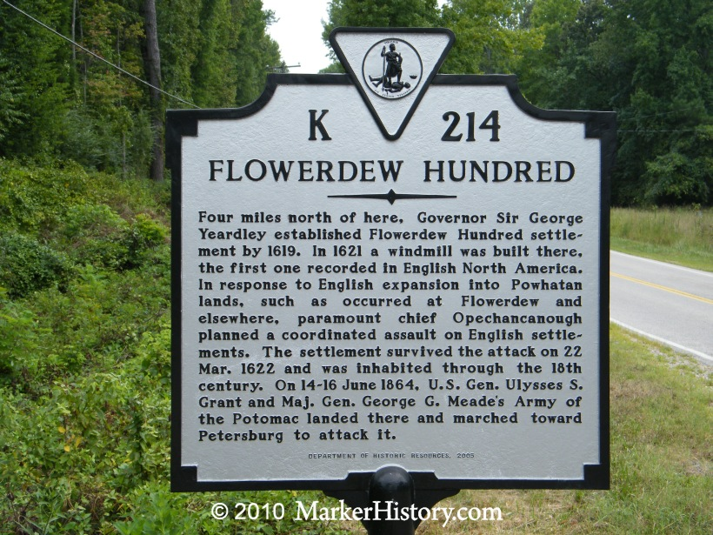

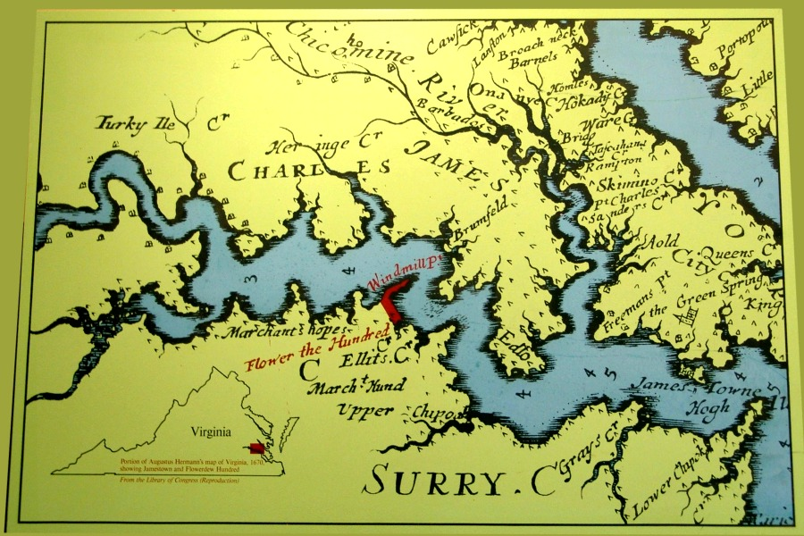
Old map of the James River showing the location of the Flowerdew Plantation and house on the south bank of the river as it crooks.

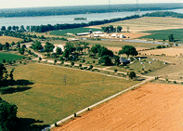
A recent photo of the Flowerdew Plantation courtesy of the Flowerdew Hundred Foundation.
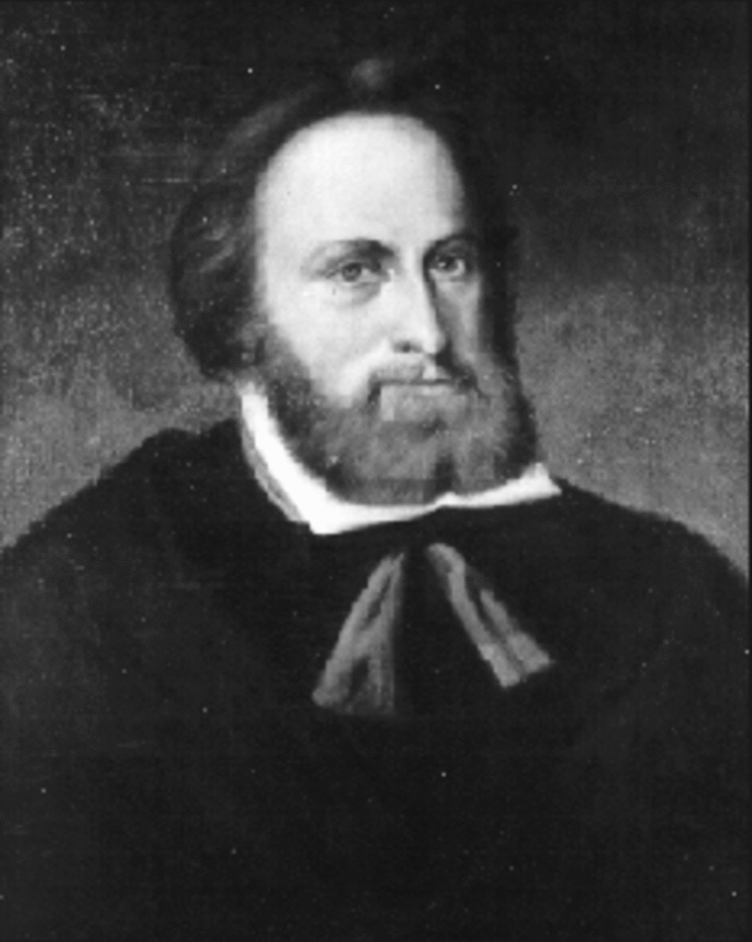
Sir George Yeardley [1587-1627], soldier and three times Governor of Virginia. Member of the relief expedition to Jamestown in 1610.
Flowerdew Hundred changed hands over the years, usually within an extended network of families linked by marriage. The spellings of the plantations name are various, from Fleur Dieu to Fludha. By 1725 the Poythress family were the owners. It was into this family that David Maitland married Susanna .
Susanna died in 1799 leaving David with 2 daughters to bring up. He soon returned to Scotland, having inherited the Barcaple estate on the death of his father. In 1804 he married Grace Gordon from nearby Campbelton, Twynholm and they lived at Barcaple until his death in 1838. Shortly after this the Fludha purchase was made and the three ladies moved out of Barcaple.
The location of Fludha, on the south of the river by the bend clearly reminded the ladies of their American roots. The River Dee standing in for the James River. The Dee itself had attractions. It was described in 1845 as,
“In summer, its margins are sweetly bedecked with wild flowers. To saunter here and listen to the mournful sound of the passing stream is to visit nature in her loveliest and most interesting form….. the river is picturesque from the rising ground at Boreland”
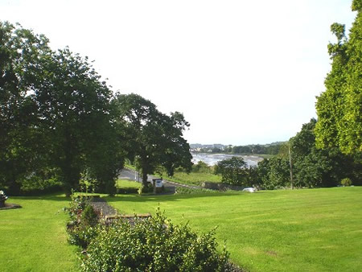
A glimpse of the view that captivated Miss Betsy and her sister.
Today’s visitors to Fludha will still be able to appreciate the view that captivated Miss Betsy and, all too briefly Susanna Maitland.
Miss Betsy lived at Fludha until her death in 1879 aged 86. In addition there was a Cook/Housekeeper, a Housemaid and a Coachman/Footman who lived in the house. Miss Betsy was buried in Tongland.
The estate was left to a cousin, David Campbell of Ayrshire but we do not have any record of him occupying Fludha. The property was purchased by a John Charters in the early 1880s. He was a coachman’s son and worked as a draper in Whithorn, evidently successfully. However, once again, there is a close connection to Barcaple. His parents, John and Grace, lived at Barcaple Cottage and John was the coachman there. Their son bought Fludha and lived there until his death in 1886.
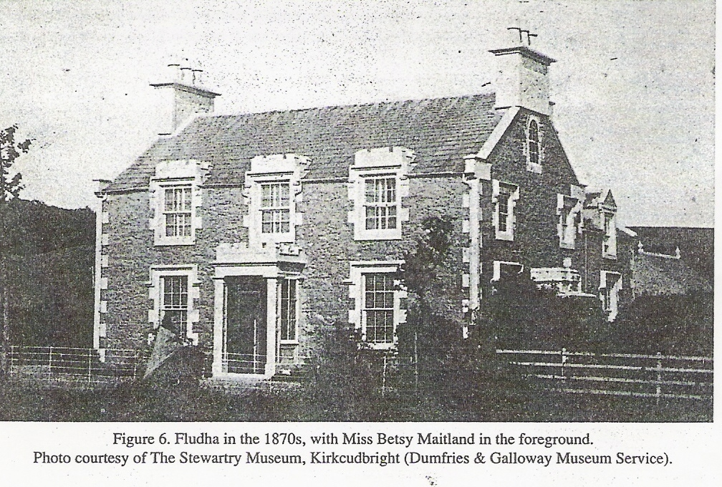
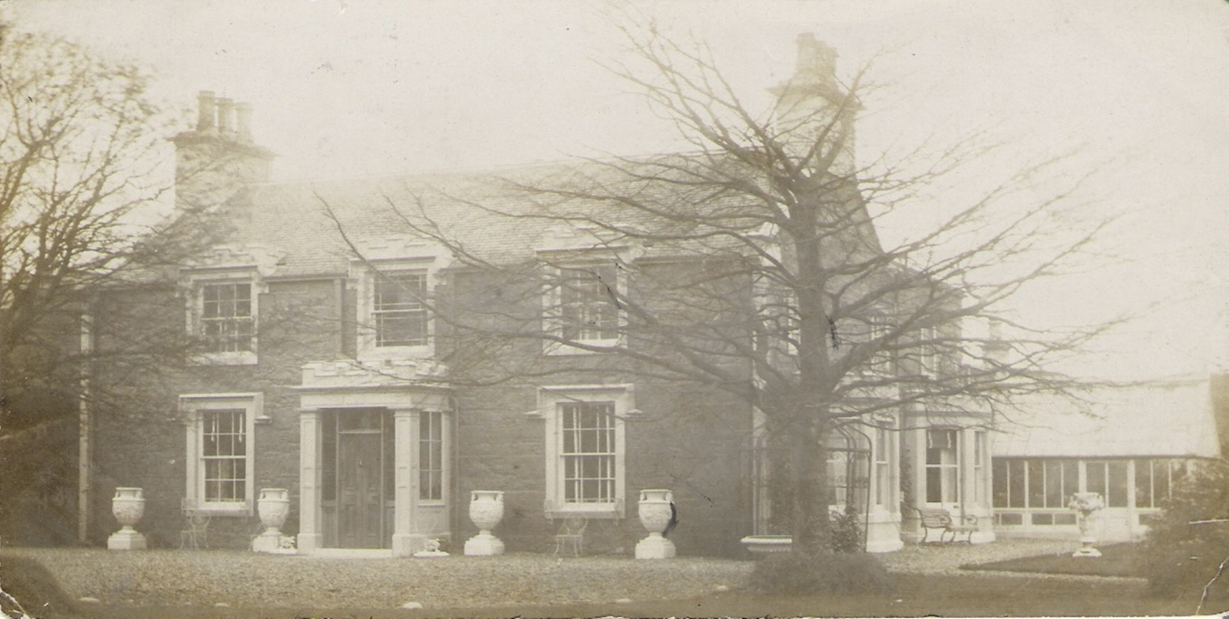

John Charters passed the house to his sister, Jane and she lived there with her niece, Grace Palmer until 1910. The census records for 1891 and 1901 only record one servant living on the premises. It may be that the ladies were able to look after the many household tasks themselves or that servants and gardeners came up for the day.
Grace Palmer inherited Fludha in 1910 and seven months later married a Kirkcudbright GP, David Jackson McAdam and they made their home here. They then went on a grand honeymoon to Canada. Unfortunately Grace took ill in Montreal and died in June 1911. David McAdam returned home to his practice and threw himself enthusiastically into the life of the community. He was a respected medical man and a very active supporter of many local groups. He was a Chairman of St Cuthberts Wanderers FC, a member of the Town Council, and a keen sailor. He particularly delighted in taking groups of young people aboard his yacht for a trip to sea. His memorial in the Dumfries Standard recalled his hearty and infectious laughter and willingness to pay for medicines for the poor out of his own pocket.
Fludha appears to have been left to a niece of Dr McAdam, Esther Jackson Campbell [Essie] who lived here until sometime in the 1960s. Essie moved in to the house with her parents, her three siblings and grandmother. In addition, she shortly married and brought her husband, Stuart Lauchlan, to Fludha too. He had been employed by the Nigerian Forestry Department and it is not clear if he travelled back to join them. By 1929, she had added a son to the inhabitants of Fludha.

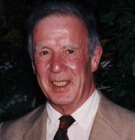Stuart Campbell Lauchlan whose mother and father owned Fludha in the 1920s. He grew up here and has many happy tales of living at Fludha. Stuart married Marian Bevan and later moved out to Warren , Rhode Island where both were doctors. Stuart died in Rhode Island in 2014.

Essie made some changes to Fludha in the 40 years or so that she lived there. The gardener’s cottage in the grounds to the north of the main building was a two roomed and basic structure. Essie had it rebuild into the two story building that exists today, called Fludha Cottage, and sold sometime in the early 1960s. It shared the old drive that was the main entrance until the existing drive was built in 2005. In addition Essie changed some of the internal features of the house. It was converted into two flats, with Essie in one and the other being rented out.
The grounds required a gardener and we know that a Mr Louden was there in the 1920s and a Mr Cole in the 1940s.

FLUDHA IN WORLD WAR TWO.

Unusually the Great War of 1914-18 appears to have left the house and its inhabitants untouched. However, Fludha was to make a more vigorous and robust contribution to the defeat of Hitler and Nazi Germany. The house made its contribution in five main areas, looking after evacuees, billeting soldiers, colleting salvage, helping to make munitions and producing food for the war effort.
Firstly, the house took evacuees from Glasgow in 1939-40. There was a great fear of the bomber and the authorities were keen to get women and children out of a key target, with its shipyards and munitions factories.
After war was declared, people expected that the Luftwaffe would bomb Britain and that civilian casualties would be enormous.
The Department of Health in Scotland spent the early months of 1939 preparing details for the evacuation of unaccompanied children, mothers with children under school age, blind people and invalids from vulnerable areas. Areas affected were Edinburgh, Rosyth, Glasgow, Clydebank, Dundee, Inverkeithing and Queensferry – and from May 1941, after the Clydeside air-raids, Greenock, Port Glasgow and Dumbarton were added.
Evacuation was voluntary. Some had made private arrangements but when the order came at 11.07 on 31 August 1939 to ‘Evacuate Forthwith’, nearly 176,000 children assembled; 120,000 leaving Glasgow within three days. By Christmas 1939, the feared German blitzkrieg hadn’t happened and three-quarters of the evacuees had returned home. Sometimes children were sent on their own or whole families came down. Fludha put up a family from Glasgow under instruction from the government and the children would have been enrolled in the local schools. One school that has recorded its evacuation to Kirkcudbright was Greenfield School in Govan. Eventually they went back to Glasgow. Locals, including Stuart Lauchlan took the view that the quiet of Kirkcudbright was too hard to adjust to for city folk.

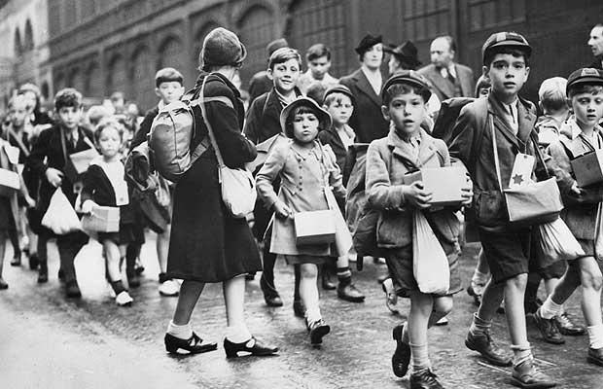
Evacuee children being marshalled for the removal from the cities.

However, once the government sponsored family had returned, Fludha had others who came down privately during the bad bombing phases later in the war.
Kirkcudbright has an army training range and a large number of soldiers were trained their and billeted in the town and surrounding farms. Fludha took its share of soldiers, particularly when a nearby farms were requisitioned as a tank range. Fludha had a number of soldiers, ranging from officers to enlisted men. Ronald Searle, the creator of the St Trinians cartoons was one of the soldiers billeted in the town. He got the idea from talking to two young girls who had been evacuated to Kirkcudbright. His memories of the town are very warm and typical.
"[Those families in Kirkcudbright] opened their doors with a generosity that made life unbelievably tolerable for a bunch of miserable soldiers."
The Army Commando unit that was stationed there from 1943 onwards is particularly remembered for their fitness and for their sense of fun. They became almost part of the Lauchlan family. They were training for D Day and the family were relieved that they all survived, although one was badly wounded. It looks like the men were from either No 4 or No 6 Commando.
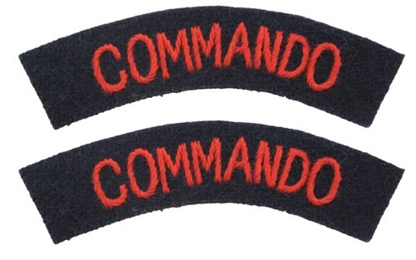

Fludha also made a contribution to the war effort by sacrificing their aluminium cookware to help build spitfires and hurricanes. Stuart Lachlan went out every Saturday morning with the Scouts, like thousands of others, to enthusiastically collect material that could be recycled for the war effort. Many accounts from residents during the war recall the Scout trek cart on a Saturday morning. The inhabitants of Fludha rather dreamed that one of their pans had shot down a German bomber or two.
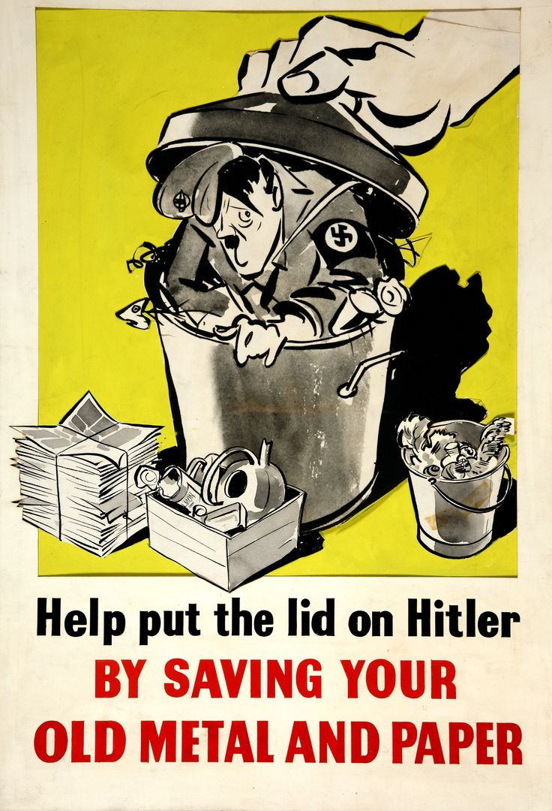

Stuart Lauchlan had retired from his post with the Nigerian Forestry Commision. However he volunteered to work on munitions production for the war effort. He became a shift chemist and travelled to Dalbeattie on the train that ran about 20 metres from his boundary to make nitro-glycerine and cordite. This material was used to fill shells and as propellant for the shells and rifle bullets. He also practiced rifle shooting with his son just in case the German should make an appearance in Kirkcudbright’s streets.
Due to the U boat menace, Britain was rather short of food. Fludha, having over 2 acres of land was well placed to become reasonably self-sufficient in such things as fruit and vegetables. The greenhouse on the south side of the house and the one to the rear were fully utilised and there was a walled vegetable and fruit garden. Apples were grown and carefully laid out in the fruit store at the rear. Soft fruits were made into jams and chutneys. Plums, loganberries, gooseberries, currants, and strawberries were carefully grown and stored. Brambles, crab apples and mushrooms were gathered for the surrounding area. Rosehips, a valuable source of Vitamin C were gathered as well. Today the bramble bushes and crab apple trees along the Dee Walk continue to offer their bounty. Much of the vegetable garden would be laid out for the growing of potatoes during the war, with carrots and onions. In addition, Fludha kept a full supply of chickens, geese, ducks, rabbits, turkeys and bees. The average ration was meagre and country folk were luckier than city dwellers in that they could produce extra food.

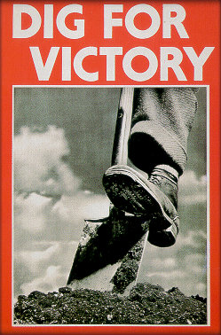
Food Rations during World War II

This is a list of the average rations that each person was allowed for one week. Although at that time Britain the pounds and ounces system of measuring weights, the amounts are shown here in metric.

• 115g cheese
• 115g bacon and ham
• 55g butter
• 55g cooking fat
• 55g margarine
• 225g sugar
• 115g jam
• 75g sweets
• 50g tea adults only
• Approximately 350g of minced beef or meat of an equivalent value
• 1 fresh egg (children were allowed 3 eggs)
• 3 eggs as dried egg powder
• 7 pints of milk for children under five
• 3 ½ pints of milk for school aged children most of whom also had school milk
• 1 pint’s worth of dried milk

However Fludha did not escape unscathed during World War Two. Possibly the Germans were aware of its contribution to the war effort. A German bomber on its way back from Glasgow or Clydebank dropped its bombs on an abandoned farm nearby. The blast woke up Mr and Mrs Lauchlan and dislodged some plaster from the bedroom ceiling. In addition, the base of the water fountain was cracked and it never worked again. Interestingly this has now been re purposed as a “Sunken Patio”, and a new fountain was put in by Stephen Laycock in 2010.

Bringing Fludha up to Date
When we first saw Fludha for sale we immediately saw its potential for conversion, its position made it highly desirable, Location Location! When we purchased Fludha in 2005 from the deceased Miss Fraser’s estate we found that although she owned it all, in many respects it was still two separate flats. It had two lots of wiring (all needing replacing, two bathrooms (neither En-Suite, one serving each level, the main central staircase had been removed and access to the upstairs flat was via a back door and a servants staircase.

We set about installing a new water supply and totally re plumbing the house to provide En-Suite bathrooms for 6 guest rooms, re wired to comply with modern commercial property standards and installed a high pressure fully automatic fire extinguishing sprinkler system fed directly from the reservoir behind the property so that if required it can put any fire out. We totally rewired the entire house and included fire alarms and emergency lighting. We (with great difficulty) designed and had built a new oak central staircase to comply with modern building standards. We combined 3 rooms into one to create our kitchen, we had to dismantle two chimneys and a 2ft thick internal wall to achieve this!
New sash and case double glazing and a car park served by the new driveway were also added. In addition we extended the property and converted the stables into owners living accommodation.
The bulk of the work took over 18 month and during that time we had between 2 and 18 tradesmen on site every day, how I wish they had the same rate of pay that the original builders had! Work is still ongoing today – it never finishes!
Once structural work was completed my wife Christine set about the internal decoration and furnishing. This was done to such a standard that the Visit Scotland tourist board rated the property 5 star before it was even completed! Very sadly at just 53, she passed away in 2011 when Fludha was becoming a well established quality Guest House and employing some 10 people and having brought Fludha back into the “Grand” mansion house it had originally been.

Owners of Fludha (as at 2020)

2011- Present Mr Stephen Laycock
2005- 2011 Stephen and Christine Laycock [died Oct 2011]
2002 - 2005 Miss Fraser (A Spinster )
1998 - 2002? Mrs Amanda McQueen
Mr and Mrs Beattie

1922 -1960s Esther [Essie] Jackson Campbell [daughter of Mr and Mrs Campbell and niece of Dr McAdam] and married to Mr Stuart Lauchlan
1911-1922 Dr David Jackson McAdam [husband of Grace Palmer]
1910- 1911 Grace Palmer [niece of Jane Charters]
1886-1910 Jane Charters [sister of John Charters]
1881 -1886 John Charters
1839-1879 Elizabeth Agnes Maitland [Betsy]

